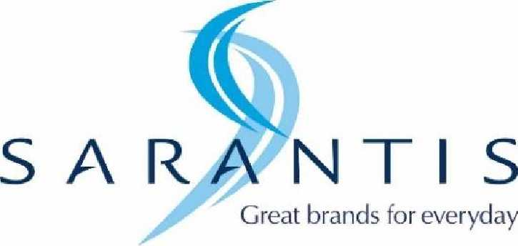

INFORMATION ON THE IMPLEMENTED TAX STRATEGY
FOR THE FISCAL YEAR 2021
This document constitutes the realization by Sarantis Polska S.A. with its registered office in
Piaseczno (hereinafter: "the Company") of its obligation under Article 27c of the Corporate Income Tax Act of February 15, 1992 (Journal of Laws of 2020, item 1406, unified text, as amended, hereinafter: "CIT") for the fiscal year running from January 1, 2021 to December 31, 2021.

Sarantis Polska S.A. is part of the Sarantis Group, engaged, for the most part, in the production and
distribution of cosmetic and household products.
As part of an international group, the Company adheres to and follows the rules, code of conduct
and policies of the Sarantis Group.

The Company's fiscal strategy consists of:
- complying with all legal requirements and filing all relevant tax returns and making all tax payments, in accordance with the law in force in Poland;
- striving to take advantage of available tax benefits and incentives in a manner consistent with public policy objectives;
- adhering to appropriate processes related to tax risk management and ensuring that the Board of Directors oversees compliance with these processes.

One of the priorities of the Company's operations is to treat tax settlements as a key corporate
responsibility issue. The Company's activities in this area are carried out with due diligence by
employees with high professional qualifications.

Given the scale of operations and the size of Sarantis Polska S.A.'s tax liabilities, there may from
time to time be risks associated with the interpretation of tax laws due to their complex nature.
The Company proactively identifies, assesses, monitors and manages these risks to ensure that
compliance with tax obligations remains in line with the Company's objectives. The Company's
tax risk management processes are aligned with the procedures and control policies in place
throughout the Sarantis Group, and are designed to fulfill all tax obligations under the tax laws as
defined in Article 3, Section 2 of the Tax Ordinance. When tax risks are identified, the Company
takes measures to mitigate these risks, which ensures the application of risk management
procedures and dialogue with the Polish tax authorities. In case of significant uncertainties or
complex issues with respect to a given risk, the Company may use the services of tax advisors.

Guided by the content and requirements indicated in Article 27c, paragraph 2 of the Corporate
Income Tax Act (Journal of Laws of 2020, item 1406), the Company would like to make the
following statements:
- Information on the Company's processes and procedures for managing the performance of tax law obligations and ensuring their proper execution.
The Company has appropriate procedures and processes in place to manage the performance of
its tax obligations - in particular, the procedure for counteracting the failure to provide
information on tax schemes.

- Information on the voluntary forms of cooperation with the National Tax Administration authorities used by the Company.
The Company has not participated in any of the voluntary forms of cooperation with the National
Tax Administration authorities.
Regardless of this, the Company cooperates with the tax authorities in a transparent and reliable
manner, providing all required information and explanations in the field of tax settlements.

- Information regarding the Company's implementation of tax obligations in the territory of the Republic of Poland, including information on the number of information provided to the Head of the National Tax Administration on tax schemes referred to in Article 86a § 1 item 10 of the Tax Ordinance, broken down by the taxes to which they relate.
The Company carried out its tax obligations in the territory of the Republic of Poland in a timely
manner and with due diligence, which result from the applicable laws. At the same time, the
Company did not provide the Head of the National Tax Administration with any information on
tax schemes, due to the lack of existence of tax schemes that would require such notification.

- Information on transactions with related parties within the meaning of Article 11a (1) (4) of the CIT, the value of which exceeds 5% of total assets within the meaning of the accounting regulations, determined on the basis of the Company's last approved financial statements, including entities that are not tax residents of the Republic of Poland.
The Company has been involved in transactions with related parties involving the purchase of
goods and the granting of a loan, the value of which exceeded 5% of the balance sheet total assets
within the meaning of the accounting regulations, as determined on the basis of the last approved
financial statements of the Company.

- Restructuring activities planned or undertaken by the Company that may affect the tax liability of the taxpayer or related parties. The Company has not conducted or planned to conduct restructuring activities that could affect the amount of its tax liabilities or the tax liabilities of related parties.
- Information on applications for general tax interpretations submitted by the Company.
The Company has not filed applications for a general tax interpretation as referred to in Article
14a § 1 of the OP.

- Information on applications for tax law interpretations submitted by the Company.
In 2021, the Company did not file applications for tax law interpretations referred to in Article
14b of the OP.

- Information on applications submitted by the Company for the issuance of binding rate information.
In 2021, the Company did not file applications for the issuance of binding rate information
referred to in Article 42a of the Law on Value Added Tax of March 11, 2004 (Journal of Laws of
2020, item 106, unified text, as amended).

- Information on applications for binding excise information submitted by the Company.
The Company in 2021 did not submit applications for the issuance of binding excise information
referred to in Article 7d paragraph 1 of the Excise Tax Act of December 6, 2008 (Journal of Laws
of 2020, item 722, unified text, as amended).

- Information on making tax settlements of the Company in territories or countries practicing harmful tax competition.
The Company did not make tax settlements in territories or countries applying harmful tax
competition indicated in the executive acts issued pursuant to Article 11 j (2) of the CIT and
pursuant to Article 23v (2) of the Personal Income Tax Act of July 26, 1991 (Journal of Laws of
2020, item 1426, unified text, as amended) and in the announcement of the Minister responsible
for public finance issued pursuant to Article 86a § 10 of the Tax Ordinance.

The information contained herein has been published with respect to information covered by the
Company's commercial, industrial and professional secrets.

